**List Rendering:(17)**

**Refactor:**

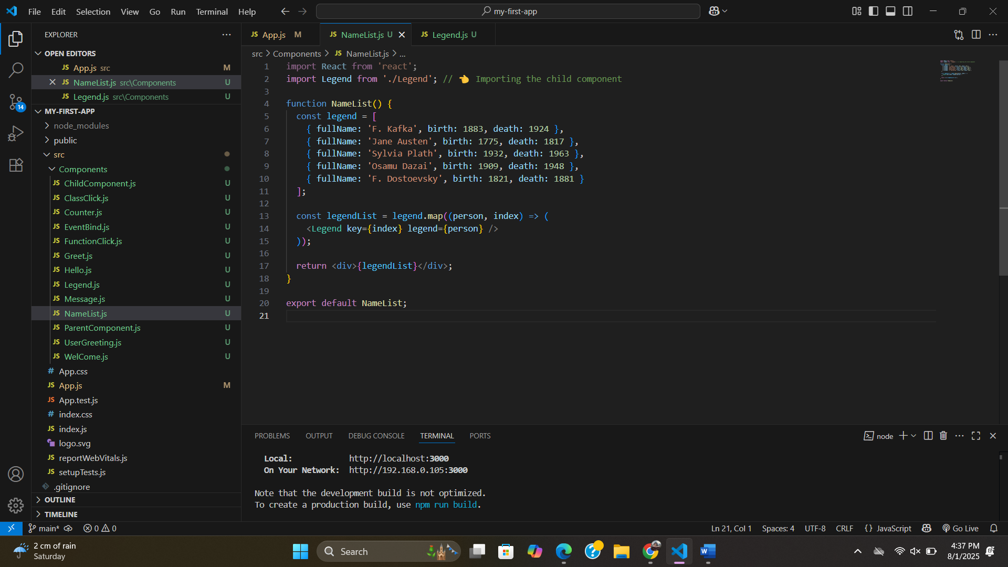

**Will do in this way:**

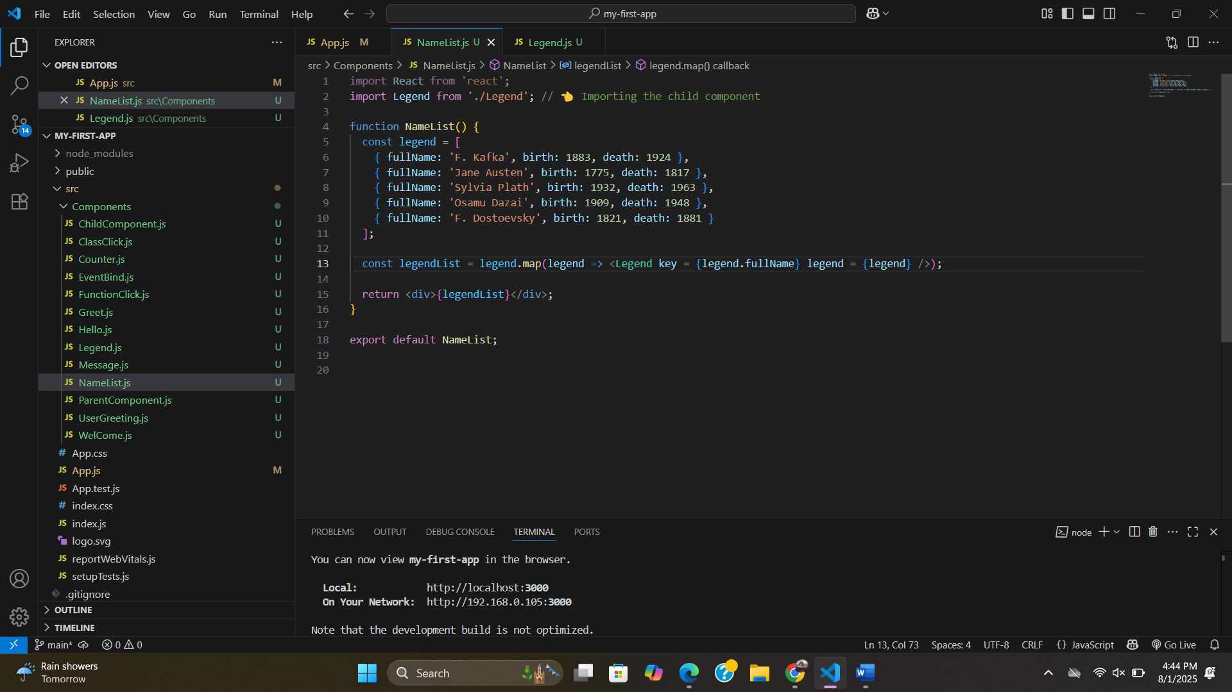

**List and key:(18)**

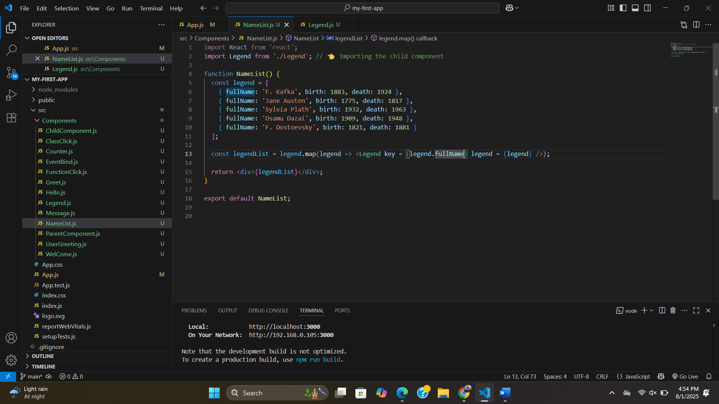

**#The key prop is not accessible in child component.**

* **A "key" is a special string attribute you need to include when creating lists of elements. Keys give the elements a stable identity.**
* **Keys help React identify which items have changed, are added, or are removed.**
* **Help in efficient update of the user interface.**

**Index as key Anti-pattern:(19)**

**When array:**

**#duplicate element then the [key prop have to be unique] then use index.but it cause some serious UI issue sometimes**

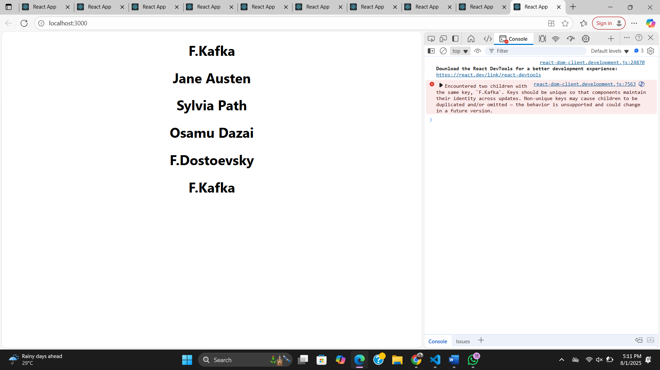

**With index:(index as key)**

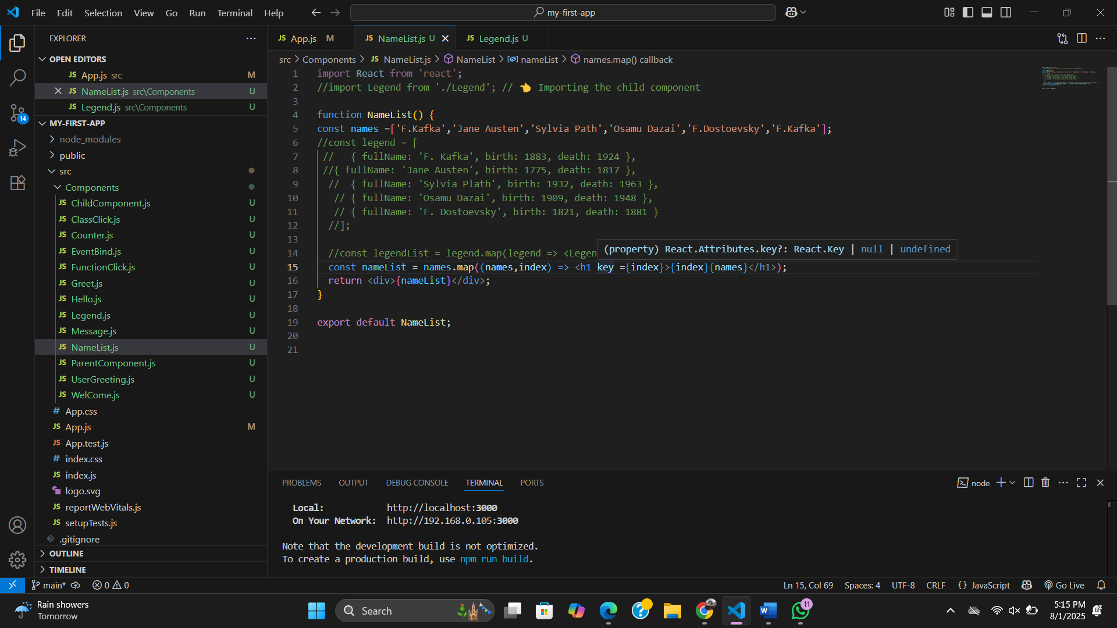

**When to use index as a key?**

**1. The items in your list do not have a unique id.**

**2. The list is a static list and will not change.**

**3. The list will never be reordered or filtered.**